1. **SQL Lesson 1 SELECT queries 101:**

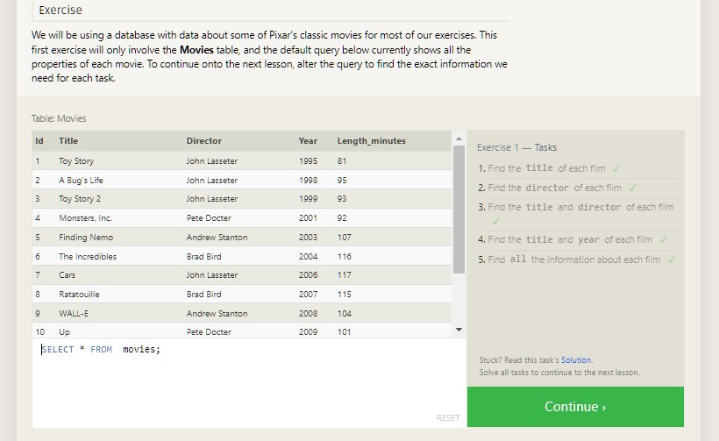

**Answer:**

* 1. SELECT title FROM movies;
  2. SELECT director FROM movies;
  3. SELECT title, director FROM movies;
  4. SELECT title, year FROM movies;
  5. SELECT * FROM movies;

1. **SQL Lesson 2: Queries with constraints (Pt.1):**

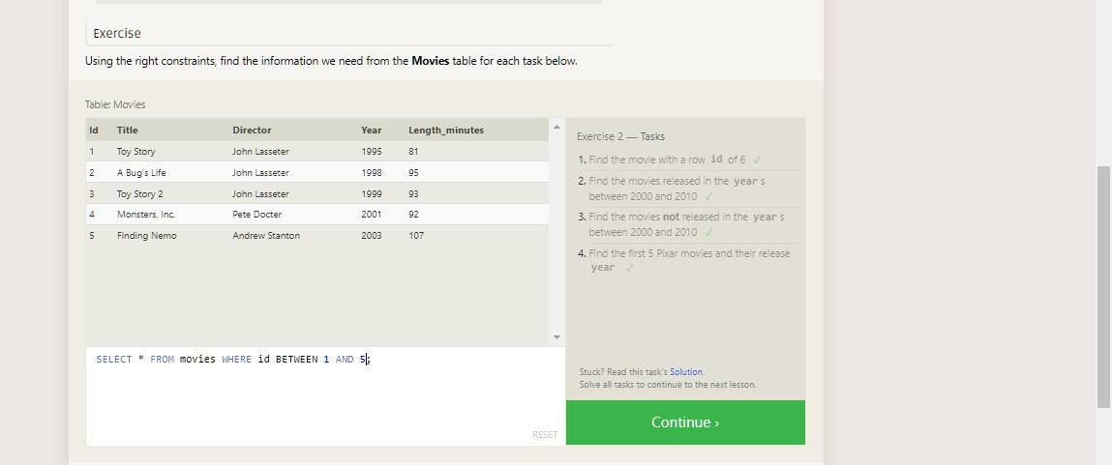

Answer:

* 1. **SELECT * FROM movies WHERE id = 6;**
  2. **SELECT * FROM movies WHERE year BETWEEN 2000 AND 2010;**
  3. **SELECT * FROM movies WHERE year NOT BETWEEN 2000 AND 2010;**
  4. **SELECT * FROM movies WHERE id BETWEEN 1 AND 5;**

1. **SQL Lesson 3: Queries with constraints(Pt. 2)**

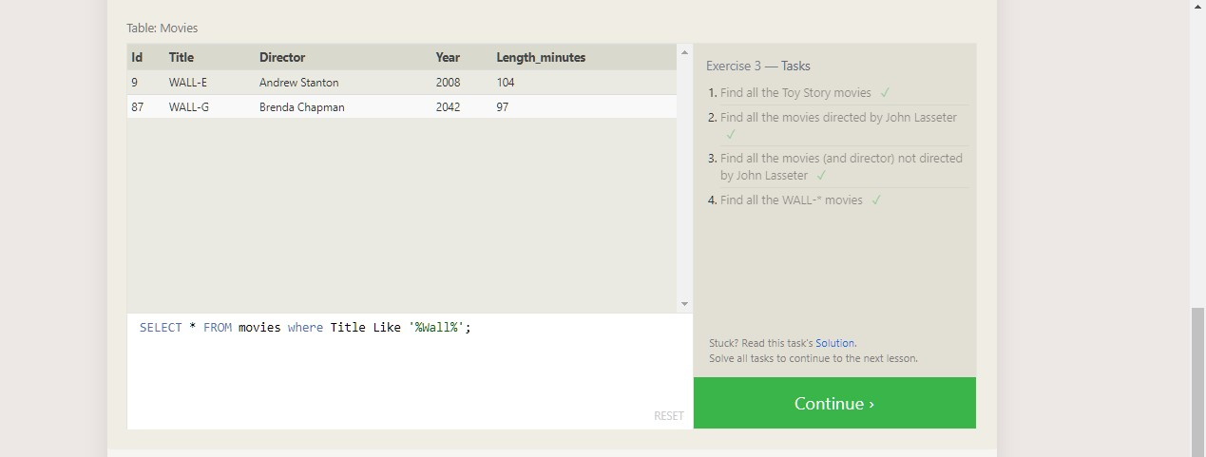

Answer:

* 1. **SELECT * FROM movies where Title Like '%Toy Story%';**
  2. **SELECT * FROM movies where Director Like '%john Lasseter%';**
  3. **SELECT * FROM movies where Director NOT Like '%john Lasseter%';**
  4. **SELECT * FROM movies where Title Like '%Wall%';**

1. **SQL Lesson 4: Filtering and sorting Query results:**

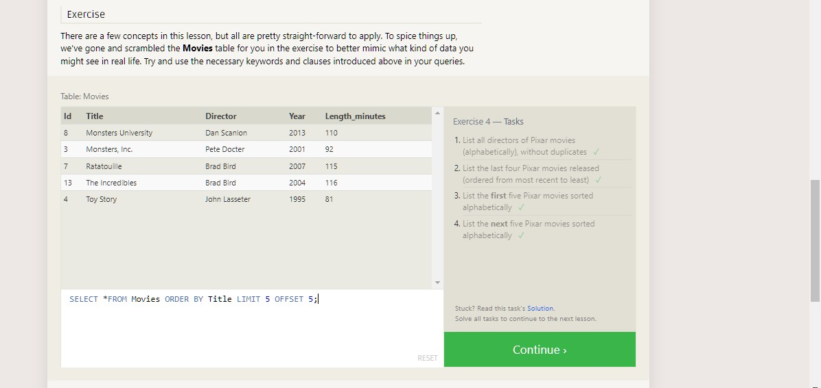

Answer:

* 1. **SELECT distinct Director FROM movies ORDER BY Director ASC;**
  2. **SELECT Title, Year FROM movies ORDER BY year DESCLIMIT 4;**
  3. **SELECT Title FROM Movies ORDER BY Title ASC LIMIT 5;**
  4. **SELECT Title FROM Movies ORDER BY Title ASC LIMIT 5 OFFSET 5;**

1. **SQL Review: Simple SELECT Queries:**

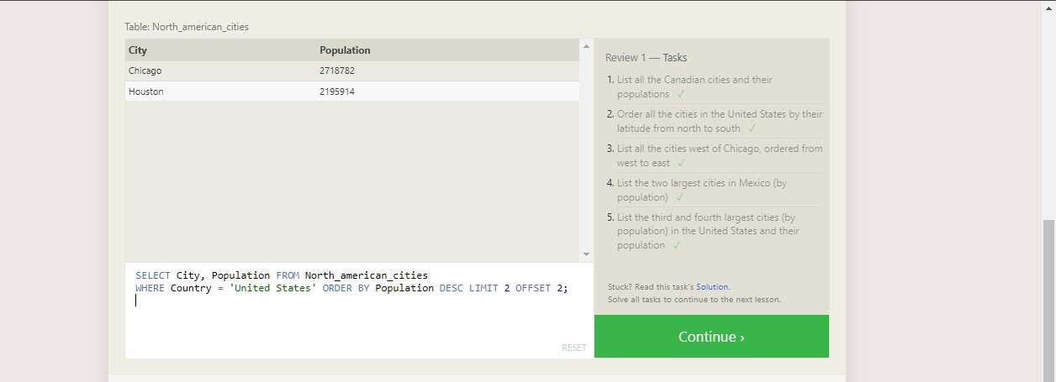

Answer

* 1. **SELECT City, Population FROM north_american_cities WHERE Country = "Canada";**
  2. **SELECT City, latitude FROM north_american_cities WHERE Country**

= "United States" ORDER BY latitude DESC;

* 1. **SELECT City, longitude FROM north_american_cities WHERE longitude < -87.629798 ORDER BY longitude ASC;**
  2. **SELECT City, Population FROM north_american_cities WHERE Country LIKE "Mexico" ORDER BY Population DESC LIMIT 2;**
  3. **SELECT City, Population FROM north_american_cities WHERE Country LIKE "United States" ORDER BY Population DESC LIMIT 2 OFFSET 2;**

1. **SQL Lesson 6: Multi-table queries with JOINs:**

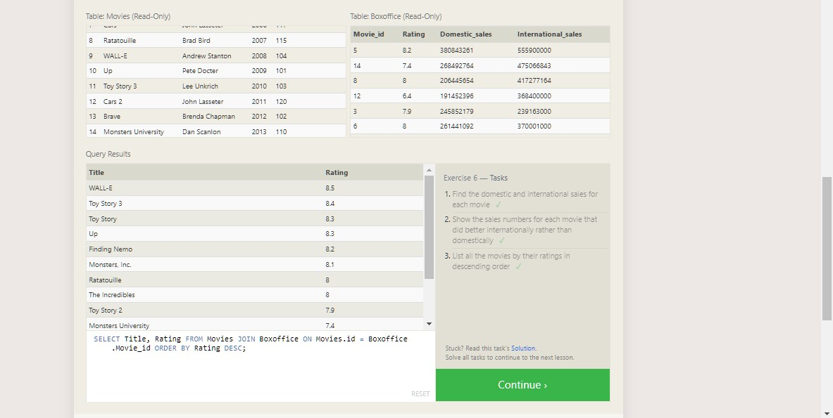

Answer:

* 1. **SELECT Title, Domestic_sales, International_sales FROM movies JOIN Boxoffice ON Movies.id = Boxoffice.movie_id;**
  2. **SELECT Title, Domestic_sales, International_sales FROM Movies JOIN BoxofficeON Movies.id = Boxoffice.movie_id WHERE International_sales>Domestic_sales;**
  3. **SELECT Title, Rating FROM Movies JOIN Boxoffice ON Movies.id = Boxoffice.Movie_id ORDER BY Rating DESC;**

1. **SQL Lesson 7: OUTER JOINs:**

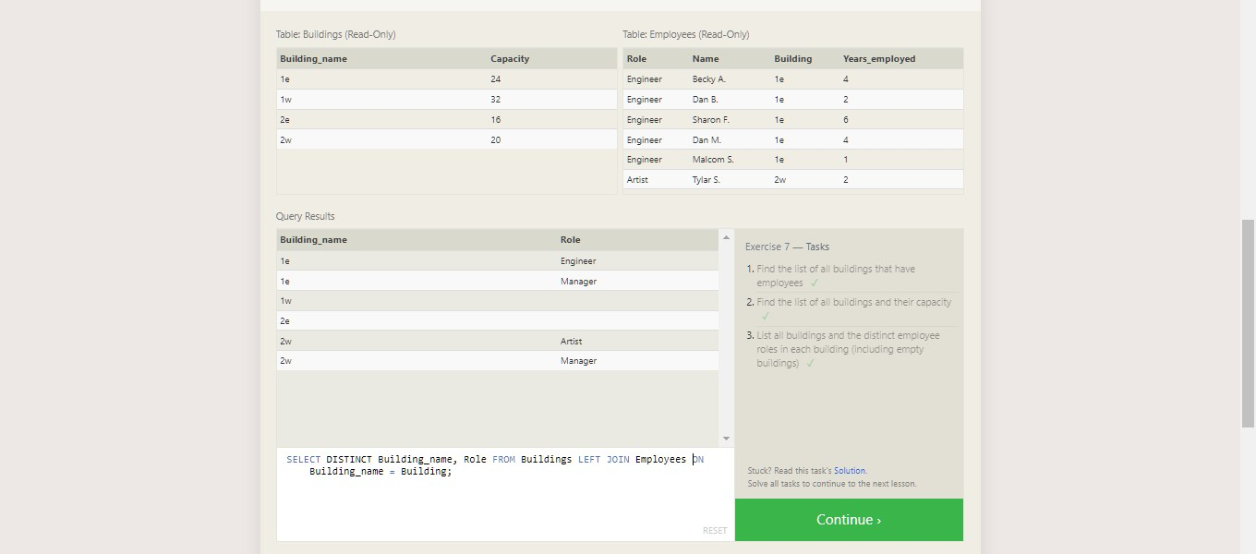

Answer:

* 1. **SELECT DISTINCT Building FROM Employees;**
  2. **SELECT * FROM Buildings;**
  3. **SELECT DISTINCT Building_name, Role FROM Buildings LEFT JOIN EmployeesON Building_name = Building;**

1. **SQL Lesson 8: A short note on NULLs:**

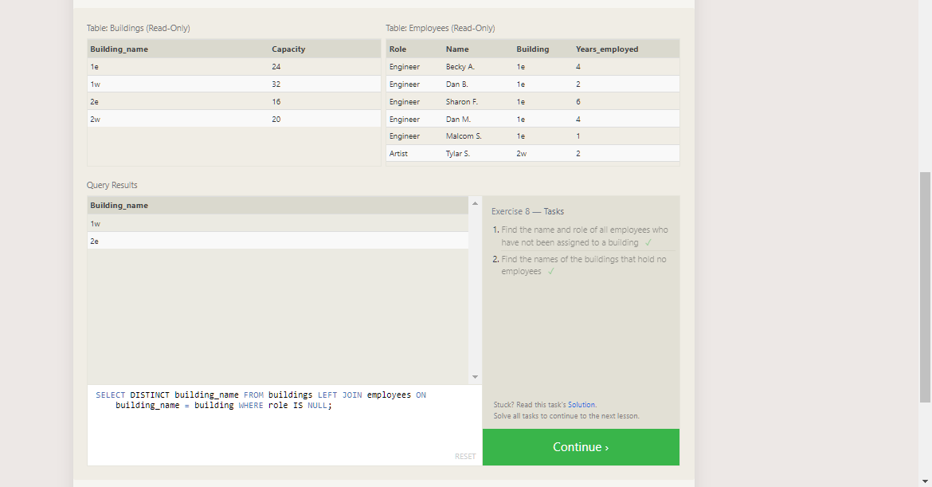

Answer:

* 1. **SELECT Name, Role FROM Employees WHERE Building IS NULL;**
  2. **SELECT DISTINCT building_name FROM buildings LEFT JOIN employees ON building_name = building WHERE role IS NULL;**

1. **SQL Lesson 9: Queries with expressions:**

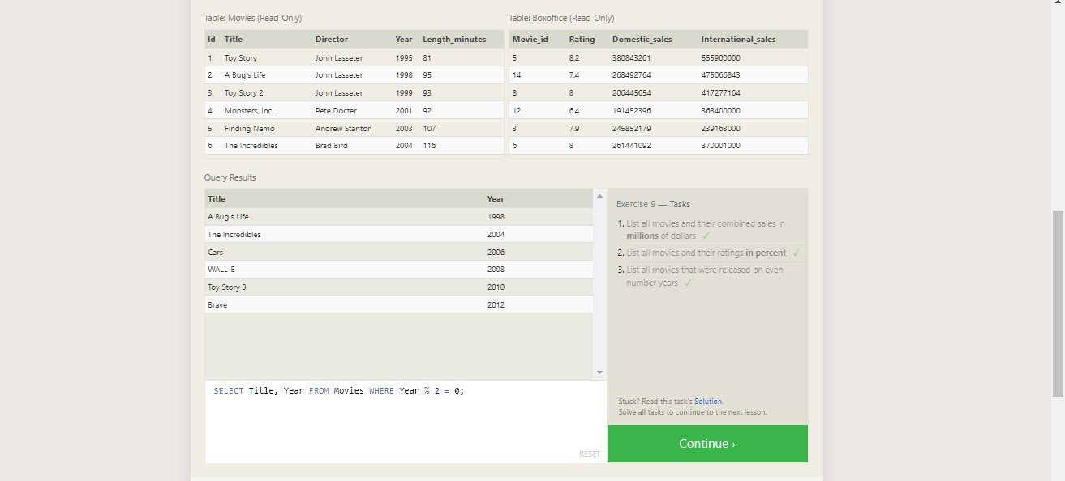

Answer:

* 1. **SELECT Title, (domestic_sales + international_sales) / 1000000 AS Gross_sales_millions FROM Movies JOIN Boxoffice ON movies.id = Boxoffice.Movie_id;**
  2. **SELECT Title, Rating * 10 AS rating_percent FROM Movies JOIN Boxoffice ON Movies.id = Boxoffice.Movie_id;**
  3. **SELECT Title, Year FROM Movies WHERE Year % 2 = 0;**

1. **SQL Lesson 10: Queries with aggregates (Pt. 1)**

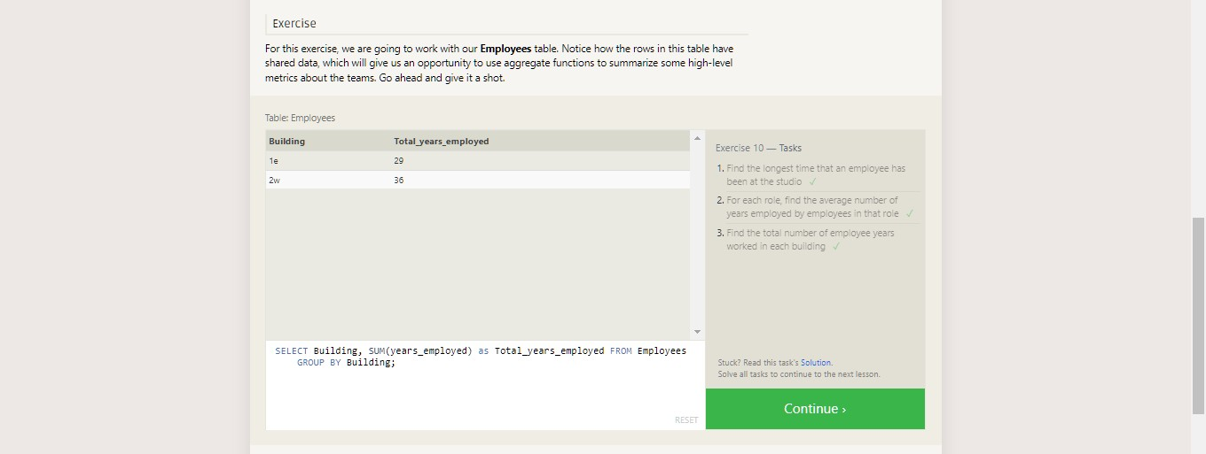

Answer:

* 1. **SELECT MAX(years_employed) as Max_years_employed FROM employees;**
  2. **SELECT Role, AVG(years_employed) as Average_years_employed FROM EmployeesGROUP BY Role;**
  3. **SELECT Building, SUM(years_employed) as Total_years_employed FROM EmployeesGROUP BY Building;**

1. **SQL Lesson 11: Queries with aggregates (Pt. 2):**

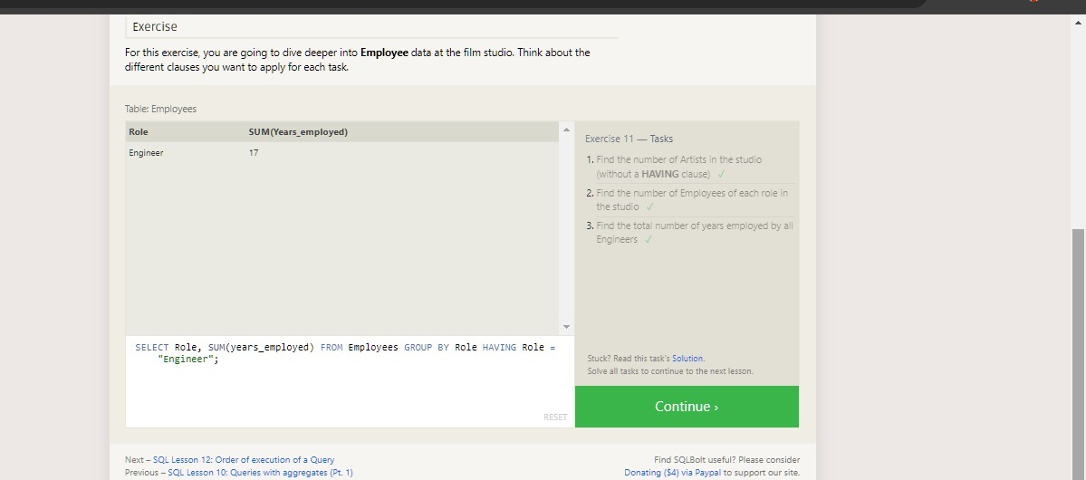

Answer:

* 1. **SELECT Role, COUNT(*) as Number_of_artists FROM Employees WHERE Role = "Artist";**
  2. **SELECT Role, COUNT(*)FROM Employees GROUP BY Role;**
  3. **SELECT Role, SUM(years_employed) FROM Employees GROUP BY Role HAVING Role = "Engineer";**

1. **SQL Lesson 12: Order of execution of a Query:**

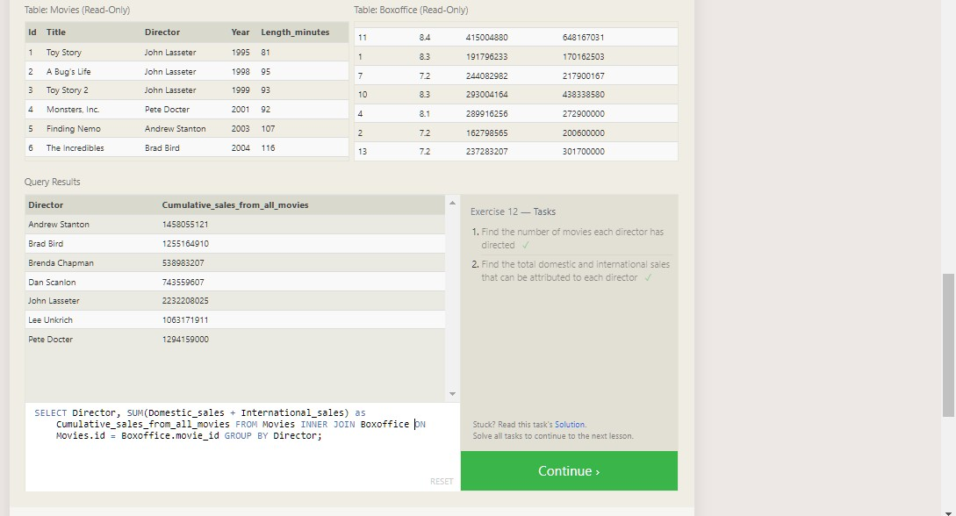

Answer:

* 1. **SELECT Director, COUNT(id) as Num_movies_directed FROM Movies GROUP BY Director;**
  2. **SELECT Director, SUM(Domestic_sales + International_sales) as Cumulative_sales_from_all_movies FROM Movies INNER JOIN BoxofficeON Movies.id = Boxoffice.movie_id GROUP BY Director;**

1. **SQL Lesson 13: Inserting rows:**

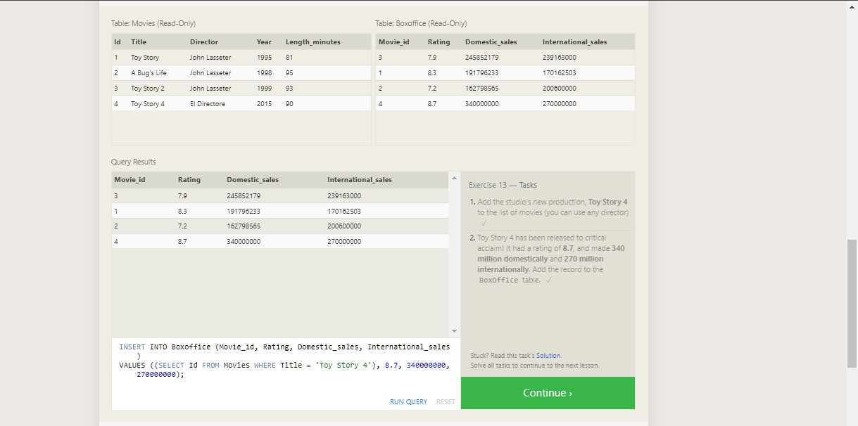

Answer

1 . INSERT INTO Movies (Title, Director, Year, Length_minutes) VALUES ('Toy Story 4', 'El Directore', 2015, 90);

2. INSERT INTO Boxoffice (Movie_id, Rating, Domestic_sales, International_sales)

VALUES ((SELECT Id FROM Movies WHERE Title = 'Toy Story 4'), 8.7, 340000000, 270000000);

1. **SQL Lesson 14: Updating rows:**

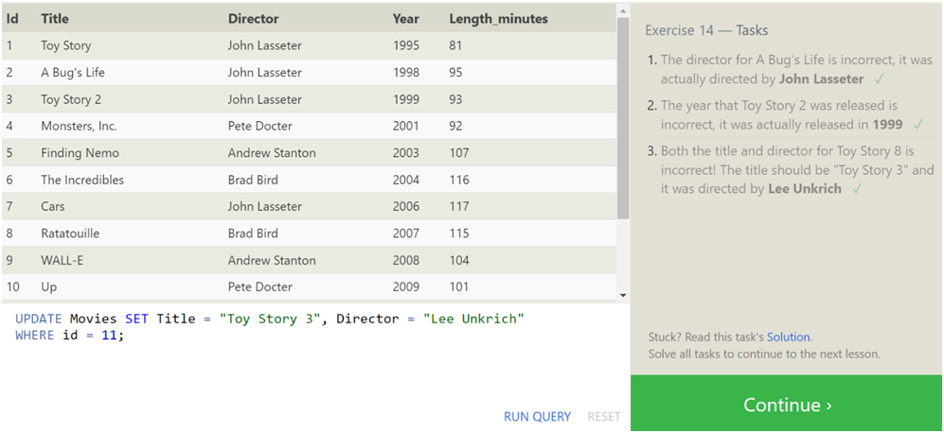

Answer:

* 1. **UPDATE Movies SET Director = "John Lasseter" WHERE id = 2;**
  2. **UPDATE Movies SET Year = 1999 WHERE Id = 3;**
  3. **UPDATE Movies SET Title = "Toy Story 3", Director = "Lee Unkrich"WHERE id = 11;**

1. **SQL Lesson 15: Deleting rows:**

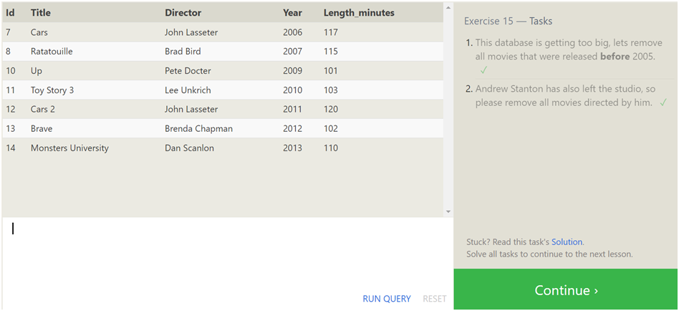

Answer:

* 1. **DELETE FROM Movies where Year < 2005;**
  2. **DELETE FROM Movies where Director = "Andrew Stanton";**

1. **SQL Lesson 16: Creating tables:**

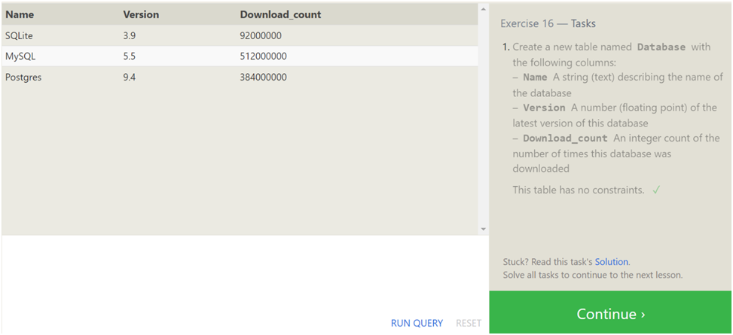

Answer:

* 1. **CREATE TABLE Database (Name TEXT, Version FLOAT,Download_count INTEGER);**

1. **SQL Lesson 17: Altering tables:**

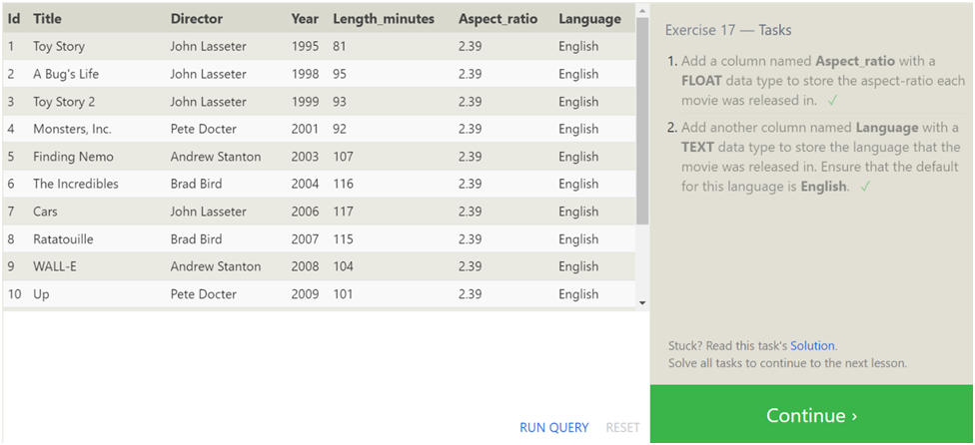

Answer:

* 1. **ALTER TABLE Movies ADD COLUMN Aspect_ratio FLOAT DEFAULT 2.39;**
  2. **ALTER TABLE Movies ADD COLUMN Language TEXT DEFAULT "English";**

1. **SQL Lesson 18: Dropping tables:**

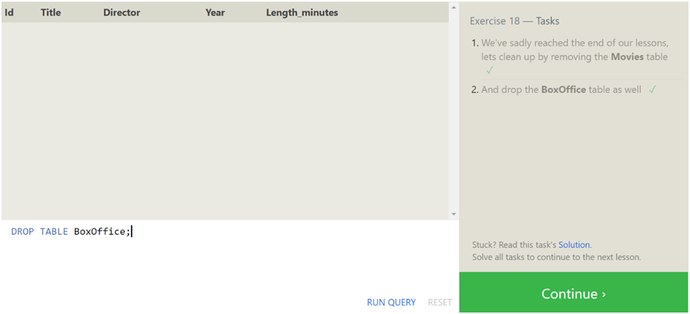

Answer:

* 1. **DROP TABLE Movies;**
  2. **DROP TABLE BoxOffice;**

